Student: Brian Johnston

Class:COP2362

Assignment 3-1

Screenshots:

STEP 9

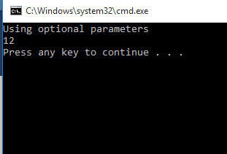

Step 12

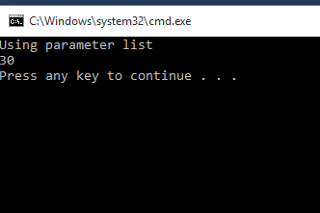

Code:

Program.CS

#region Using directives

using System;

using System.Collections.Generic;

using System.Text;

#endregion

namespace ParamsArray

{

class Program

{

static void doWork()

{

//Console.WriteLine(Util.Sum(10, 9, 8, 7, 6, 5, 4, 3, 2, 1));

Console.WriteLine(Util.Sum(2, 4, 6, 8, 10));

}

static void Main()

{

try

{

doWork();

}

catch (Exception ex)

{

Console.WriteLine("Exception: {0}", ex.Message);

}

}

}

}

Util.CS

using System;

using System.Collections.Generic;

using System.Linq;

using System.Text;

using System.Threading.Tasks;

namespace ParamsArray

{

class Util

{

public static int Sum(params int[] paramList)

{

Console.WriteLine("Using parameter list");

if (paramList == null)

{

throw new ArgumentException("Util.Sum: null parameter list");

}

if (paramList.Length == 0)

{

throw new ArgumentException("Util.Sum: empty parameter list");

}

int sumTotal = 0;

foreach (int i in paramList)

{

sumTotal += i;

}

return sumTotal;

}

public static int Sum(int param1 = 0, int param2 = 0, int param3 = 0, int param4 = 0)

{

Console.WriteLine("Using optional parameters");

int sumTotal = param1 + param2 + param3 + param4;

return sumTotal;

}

}

}